**The Need for Speed**

**RULES:** Practical Shooting Handbook, Latest Edition **COURSE DESIGNER:** Kirt McKenna

|  |  |
| --- | --- |
| **START POSITION:** Standing with wrists below belt. Handgun is unloaded and lying unpropped on barrel with muzzle pointed downrange. All loading devices start on barrel.  **PCC START:** Same as handgun. | |
| **STAGE PROCEDURE**  On start signal engage targets as they become visible, from within the shooting area. Perform a mandatory reload between Box A and Box B. All loading devices start on barrel. | **SCORING**  **SCORING:** Comstock, 16 rounds, 80 points  **TARGETS:** 8 USPSA  **SCORED HITS:** 2Best per USPSA  **START-STOP:** Audible - Last shot  **PENALTIES:** Per current USPSA rulebook |

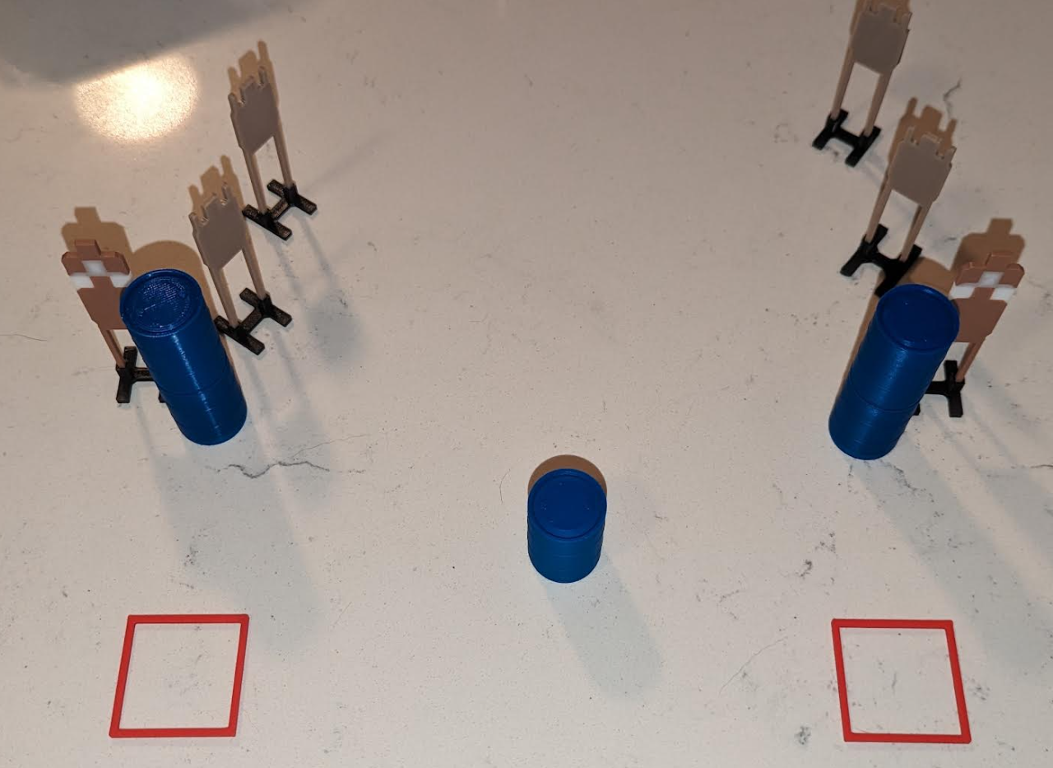

**Box B**

**Box A**

|  |  |  |
| --- | --- | --- |
| **SETUP NOTES**: Prevent shoot-throughs |  | **RO NOTES**: |